|  |  |
| --- | --- |
| **Full Name** | **Muhammad Afzal** |
| **Batch** | **MS FSD DEC 2021 Cohort 1** |
| **Student ID** | **Afzal** |
| **Project Title** | **Develop a Web Application using frontend stack.** |
| **Project Submission Date** | **July 12, 2022** |

|  |
| --- |
| Main Login |
|  |
| Main Register New User |
| Main Admin Dashboard  Admin Dash Board  All categories:  Add New Category  All Quizzes  Add New Quiz  User Dashboard:  Quiz Test  Submit Result |

# Result Page

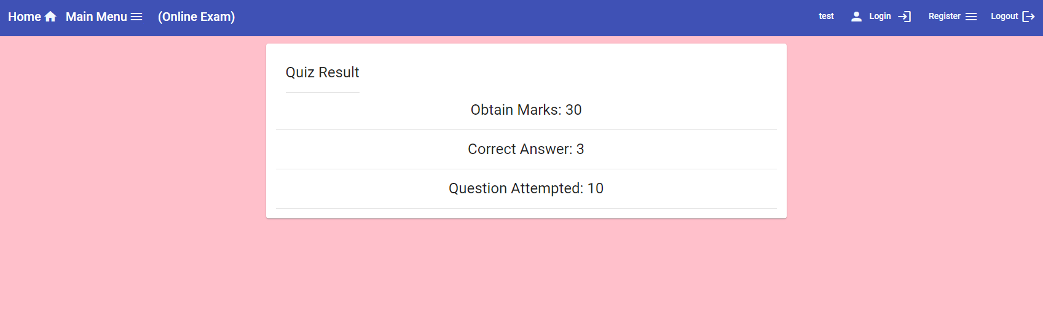

**Login Menu**

1. Login Option (it allows user to register login to user the application)

2. Menu Bar (User have option Like View Profile Home page or log out)

3. Register (User can Register login details)

**Main Menu Admin.**

1. Display the Mian Function for Admin and in Side bar we can use function as below
   1. Add new Category
   2. Add new Quiz
   3. Update the Quiz
   4. Delete the Quiz
   5. Update the Category
   6. Can see All quizzes

**User Menu**

1. (User Menu have option like
2. Can Write the exam
3. Can see all Quiz category
4. Can view the Profile
5. Show All Cla

Thank you